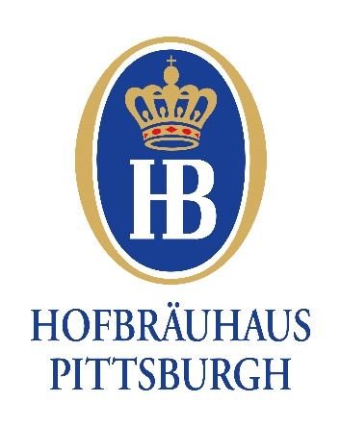

Hofbrauhaus Tour Menu - $26.95
All Guests are served with our Famous Imported German Soft Bavarian Pretzel and a House Salad

Entrée Selections:

Schweinebraten
Tender, slow cooked Pork Roast, with Vegetable garnish, dark Bier Sauce, Sauerkraut and Potato Dumpling.

Jägerschnitzel
Classic breaded Pork Cutlet fried crisp and golden brown, topped with a Burgundy Wine Mushroom Sauce. Served with German Potato Salad and Fried Cabbage.

Hofbrauhaus Wursteller
Grilled Bierwurst, Bratwurst and Frankfurter served with Sauerkraut and Mashed Potatoes.

Dunkel Bourbon Chicken
Grilled Chicken Breasts topped with Homemade Dunkel Bourbon Glaze. Served with Mashed Potatoes and Chef’s Vegetable Selection.

Dunkel Bourbon Salmon
Pan Seared Atlantic Salmon Fillet topped with our Homemade Dunkel Bourbon Glaze. Served with Mashed Potatoes and Chef’s Vegetable Selection.

*Vegetarian options available upon request

Dessert Selections:

Apfel Strudel ½ portion
Traditional homemade Bavarian Apple Strudel served with Powdered Sugar and a Haus made Sabayon Sauce

Black Forest Cake ½ portion
Traditional Black Forest Chocolate and Sweet Cream Layer Cake. 3 layers of moist Chocolate Cake with delicious Cherry Filling. Sprinkled with Chocolate Shavings.

Includes coffee, tea, soft drinks or water. Entrée prices excludes tax and gratuity

